Student Performance Prediction System

Project Id: AIML-5

Name : Harshita Joshi (Team Leader)
Class Roll Number: 06
University Roll Number :2028427
Section and Group: P G1

Name : Devesh Saini
Class Roll Number: 40
University Roll Number :2028706
Section and Group: P G1

Name : Anmol Gupta
Class Roll Number: 2028644
University Roll Number : 2028644
Section and Group: P G1

- Problem Description 3
- Architecture 4
- Models model 5
- Evaluation metrics used 6
- Preliminary Results and Visualizations 7
- References 8

- Problem Description

- Air pollution is a critical environmental issue affecting human health and ecosystems. Monitoring and predicting air quality levels is essential for taking preventive actions and ensuring public safety. However, raw sensor data alone does not provide meaningful insights without proper analysis.
- This project aims to develop an Air Quality Level Classification System using Machine Learning. The system uses environmental sensor data such as CO (Carbon Monoxide), NO₂ (Nitrogen Dioxide), Temperature, Humidity, along with contextual information like city, disease conditions, and past medical records to classify air quality into categories such as Good, Moderate, and Poor.
- By incorporating both environmental and health-related parameters, the model can better understand how pollution affects individuals with different medical conditions. Data preprocessing techniques such as handling missing values, noise removal, categorical encoding, and feature scaling are applied. Feature selection helps retain important pollution indicators and remove less useful attributes.
- The classification is performed using K-Nearest Neighbors (KNN) , Logistic Regression algorithms , Decision Tree and Support Vector Machines(SVM). The models are evaluated using accuracy, precision, recall, and F1-score. This system can assist in environmental monitoring and provide health-aware air quality recommendations.

- Architecture
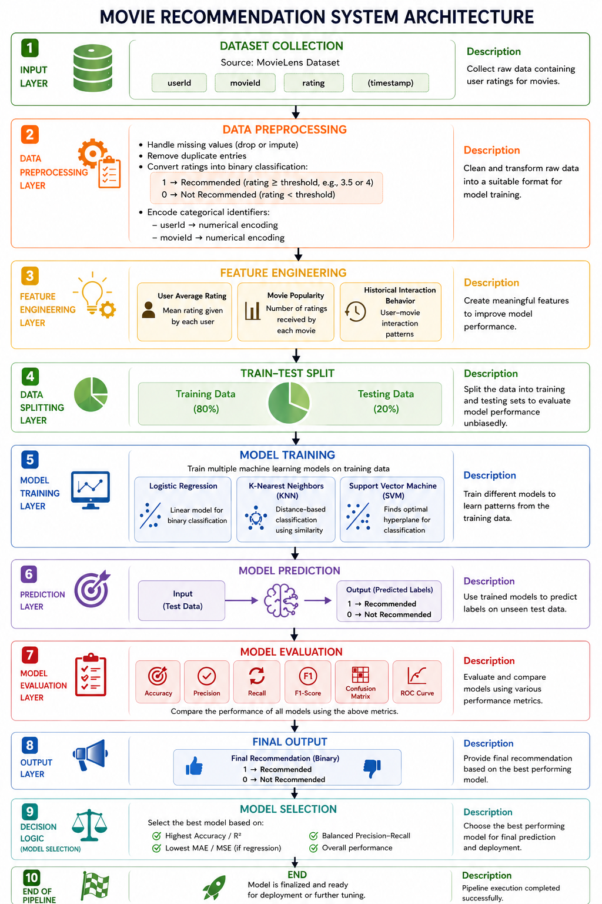

- Models Used(Applied/ Planned) Give a brief introduction of the models used
1. Logistic Regression

Logistic Regression is a supervised machine learning algorithm used for binary classification problems. It models the probability that a given input belongs to a particular class using the logistic (sigmoid) function, which maps values between 0 and 1.
It is computationally efficient, interpretable, and works well when the relationship between features and output is approximately linear.

2. K-Nearest Neighbors (KNN)

KNN is a non-parametric, instance-based learning algorithm used for both classification and regression. It classifies a data point based on the majority class of its nearest neighbors in the feature space, typically using distance metrics like Euclidean distance.
KNN is simple to implement but can be computationally expensive for large datasets.

3. Support Vector Machine (SVM)

SVM is a powerful supervised learning algorithm used for classification and regression. It works by finding the optimal hyperplane that maximizes the margin between different classes.
SVM can handle both linear and non-linear data using kernel functions such as linear, polynomial, and radial basis function (RBF), making it highly effective in complex scenarios.

4. Decision Tree

Decision Tree is a tree-based supervised learning algorithm used for classification and regression. It splits the dataset into subsets based on feature conditions, forming a tree-like structure of decisions.
It is easy to interpret and visualize but may suffer from overfitting if not properly controlled.

- Evaluation metrics used

1. Accuracy
Accuracy measures the overall correctness of the model.
$$Accuracy=\frac{TP+TN}{TP+TN+FP+FN}$$
- It shows how many predictions are correct out of total predictions.
- Best used when the dataset is balanced.

2. Precision
Precision measures how many predicted positive cases are actually positive.
$$Precision=\frac{TP}{TP+FP}$$
- Focuses on false positives.
- Important when the cost of false positives is high.

3. Recall (Sensitivity)
Recall measures how many actual positive cases are correctly identified.
$$Recall=\frac{TP}{TP+FN}$$
- Focuses on false negatives.
- Important when missing positive cases is costly.

4. F1-Score
F1-Score is the harmonic mean of Precision and Recall.
$$F1=2⋅\frac{Precision⋅Recall}{Precision+Recall}$$
- Provides a balance between precision and recall.
- Useful when dataset is imbalanced.
- 5. Preliminary Results and Visualizations
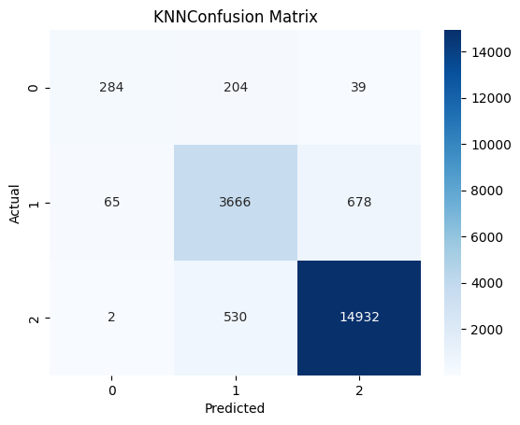
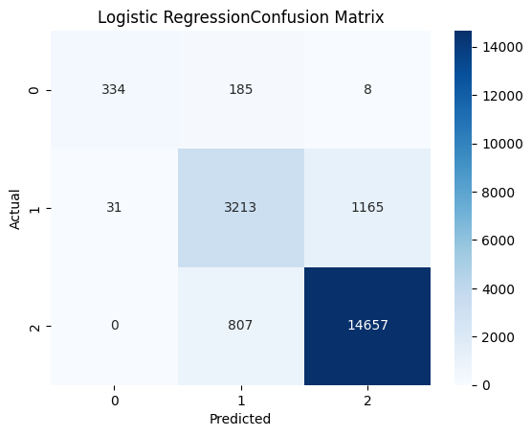
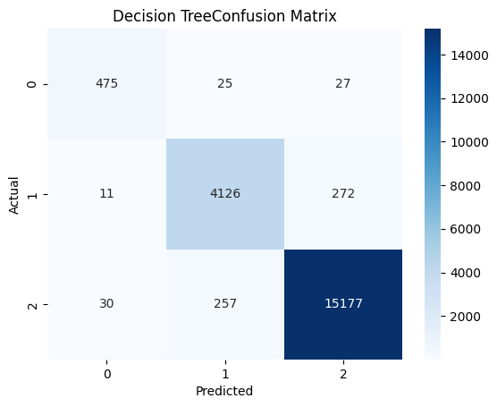
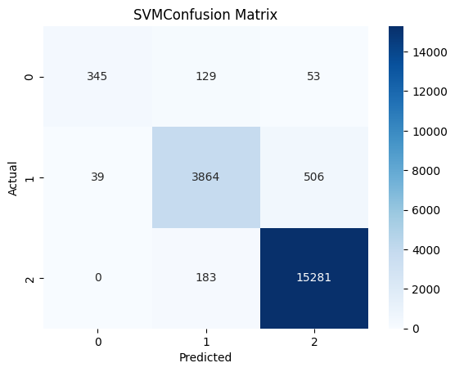

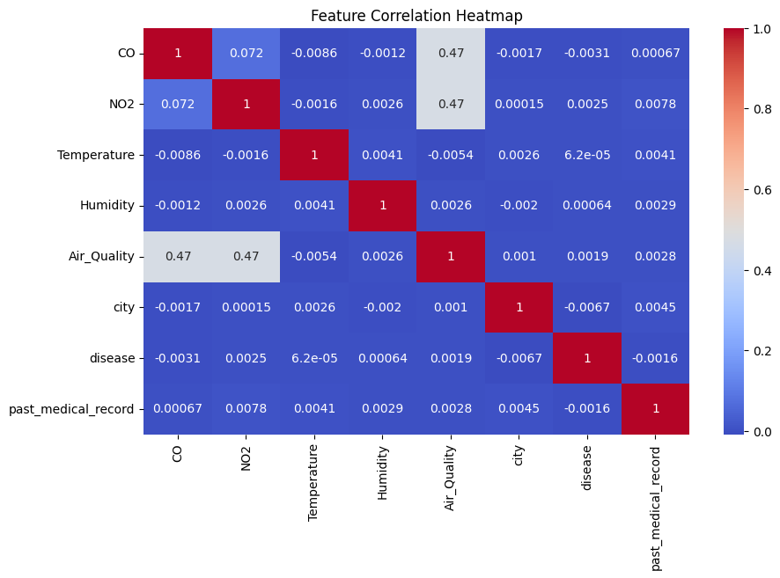
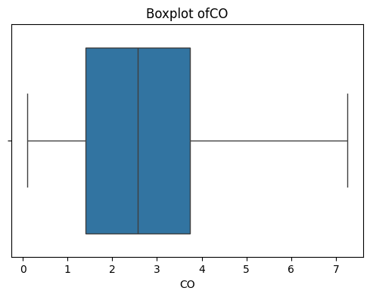

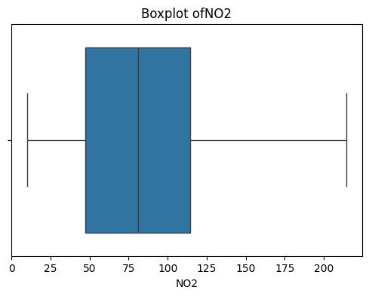
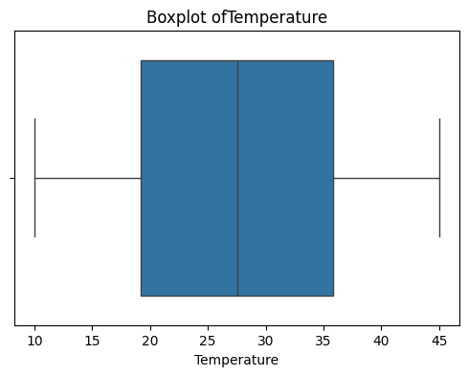
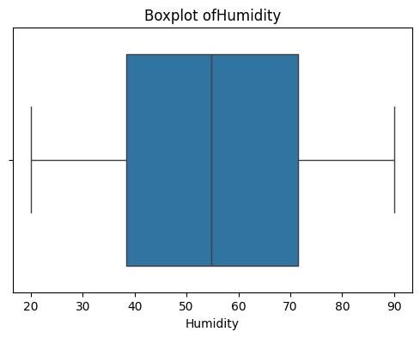
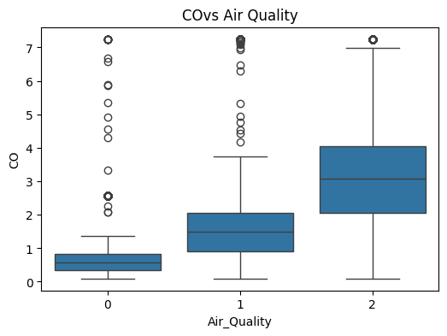
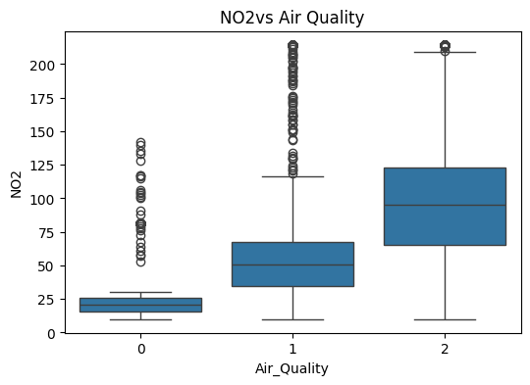
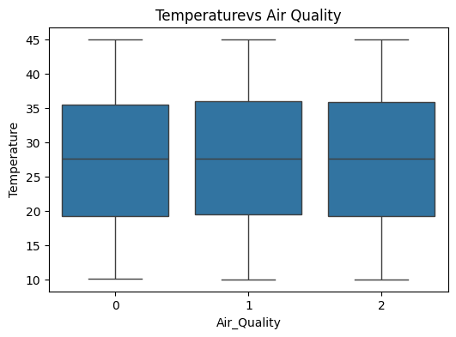
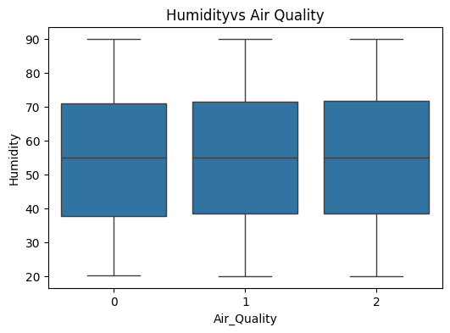
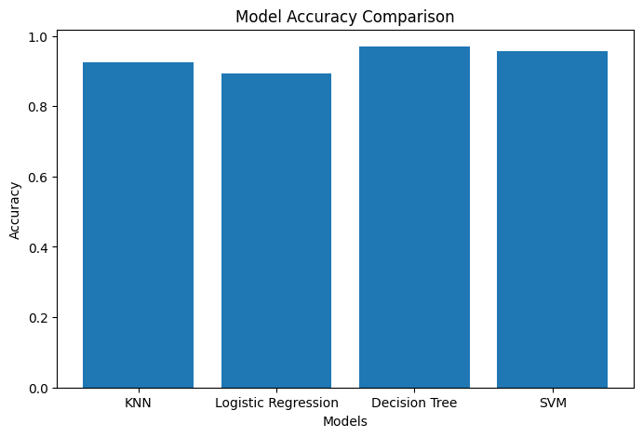
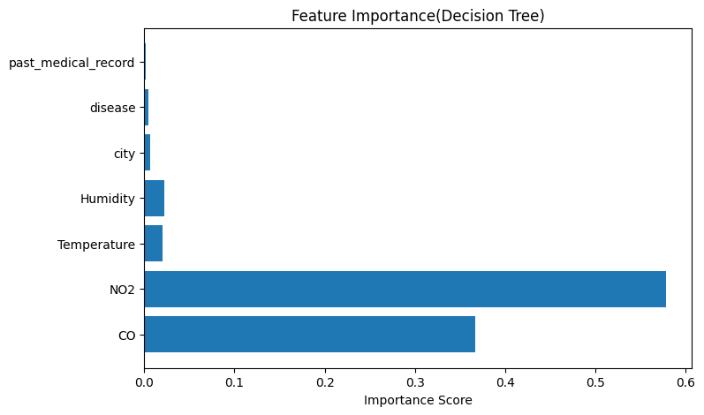
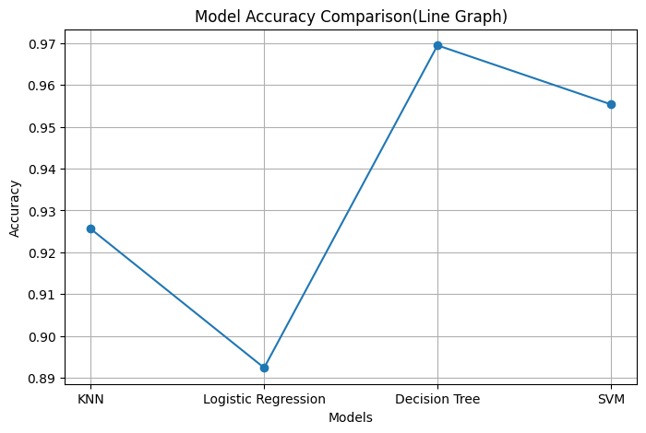
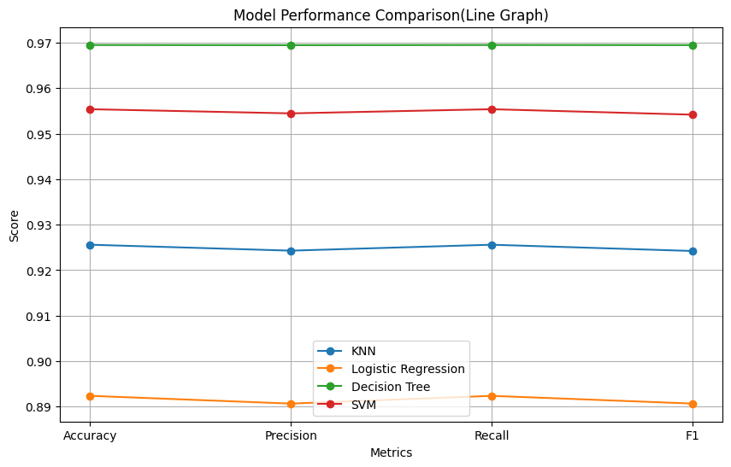

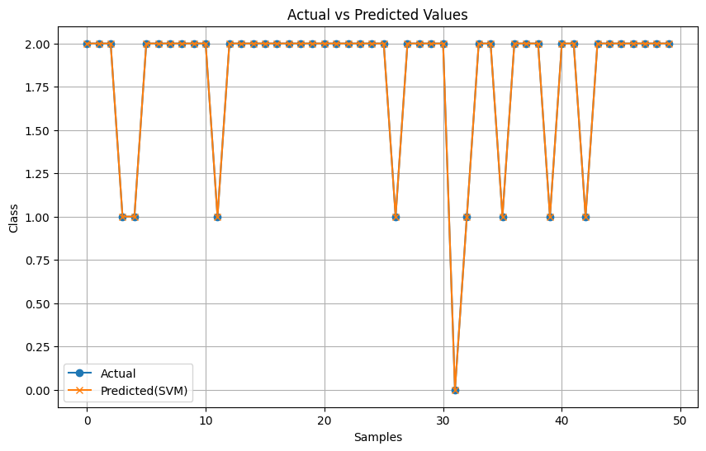
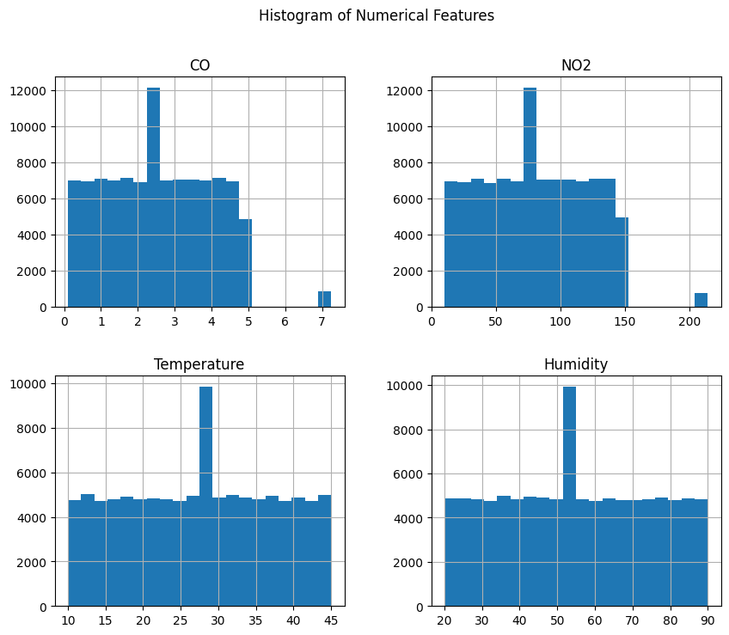

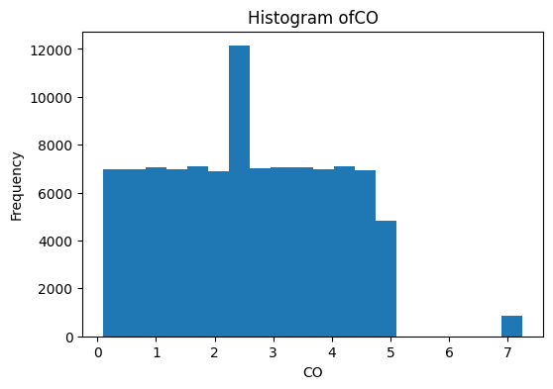
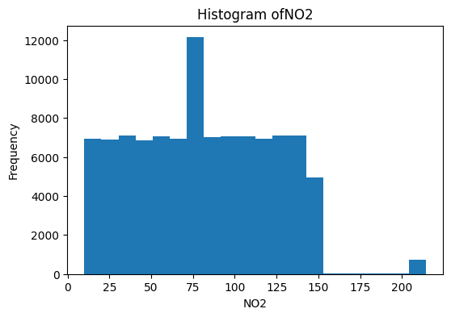
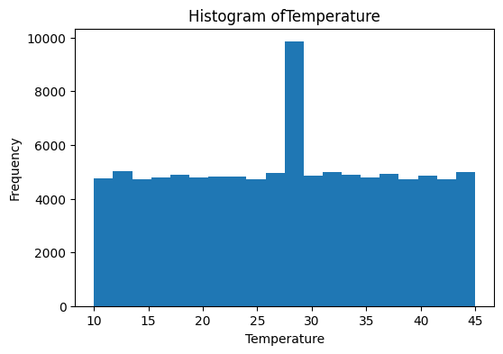
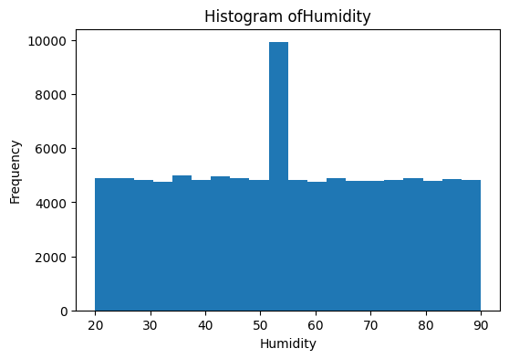
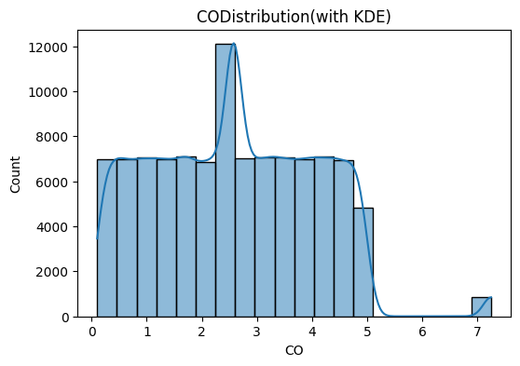
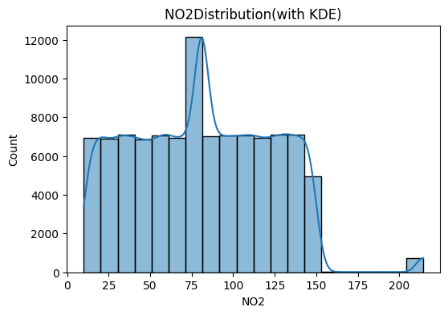
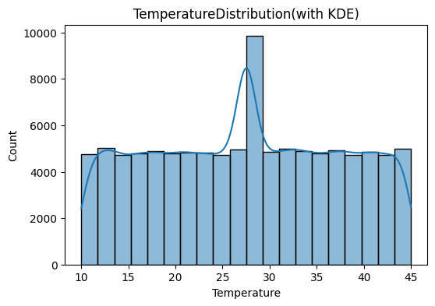
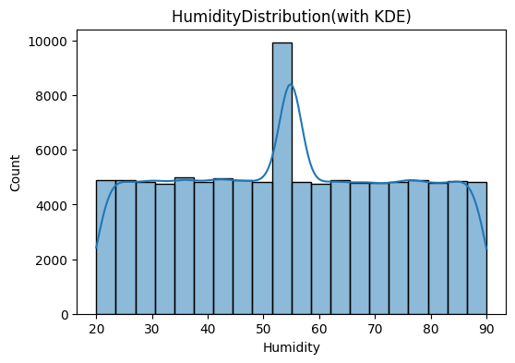
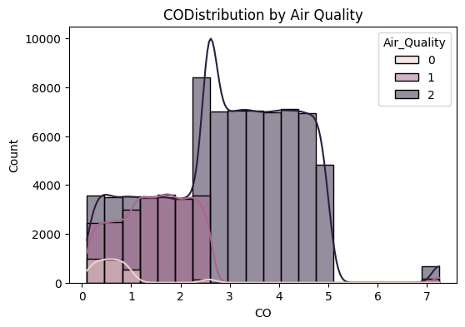
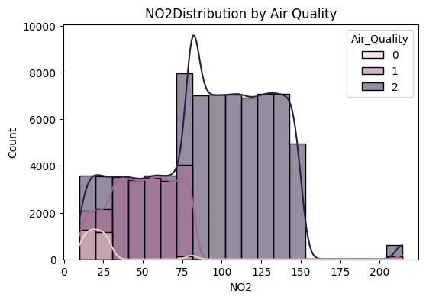
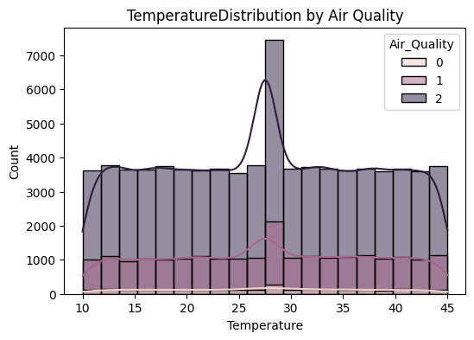
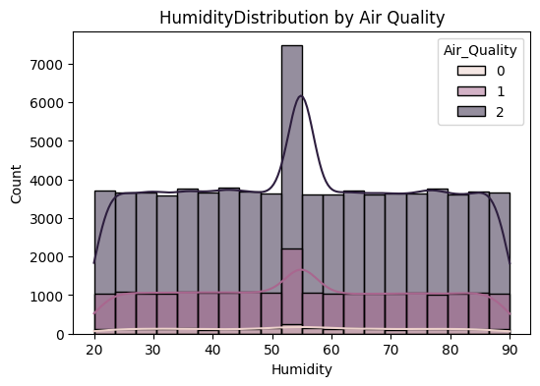
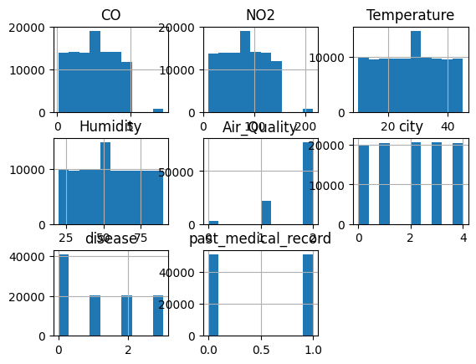

6. References:
Books:
- Let Us Python – Yashavant Kanetkar

Online Resources:
  - GeeksforGeeks – https://www.geeksforgeeks.org/
  - TutorialsPoint – https://www.tutorialspoint.com/cprogramming/index.htm
  - Stack Overflow – https://stackoverflow.com

